Submission Date: 7/21/2014
IS 250 Project Submission Report

Fill in your Last and First Name in Solution Folder Name. Make sure that you submit Solution Folder with this Word document inside it, not only this document. You can also submit a zipped copy of your Solution folder.

Solution Folder Name:

P4_Bhandari_Ananta
Solution folder name must be given in the following format:
P4_LastName_FirstName Example: P4_Norton_Peter
Project Documentation: Your program should be internally documented. Documentation includes:
- Header that must be placed at the top of the main source code module, with your name, date, purpose of the program. Example:
‘ Peter Norton
’ IS 250, Project 4: Workshop Selector
’ Project started: 1/27/2012, Project Submitted: 2/3/2012
’ Purpose of the program: …

- Remarks inside your code: purpose of all procedures, comments on variables and algorithm;
Try to comment almost every line!
- Controls and Variables Names: should all be mnemonic and follow Hungarian notation
(3 letter prefixes, SentenceCaseNoSpaces). For Example: lblGrossProduct
- Work progress time log: You must keep track of each important step of the development / debugging process (like adding a new feature, error correction, or major modification to the project) with a short description of what has been done and the date/time stamp of each step.
Example:
Student Name Project 2: States Information Program
Work Planning | Implementation Notes | Time Date:
Started to work on the project | Got tutor Andy to help | 8:00am 1/27/2012
Designed project specifications and GUI prototype | Alignment of picture boxes was an issue | 11:30am
Interface development: created controls |  | 12:05pm
Programmed event procedures | Used … property in order to | 5:50pm
… | … | 9:50pm
Corrected errors | Used breakpoints to find errors in … | 2:33am 1/29/2012
Improved layout form…. | Adjusted …. | 3:30 am
…
Submitted Solution for Grading | Most challenging in project was… Learned… | 3:00pm 2/3/2012

Completed projects must be dropped in CourseFiles Y: drive before class on the due date.
Make sure that you copy and drop the Solution Folder into the Assignment Drop Box and not move it, so that you won’t lose your copy of your project.
Each project submission should include the following:
❑ Solution Folder with all necessary files to compile and run the application
❑ This Submission Report as a word document inside root of the Submission Folder
❑ Include a copy of the source code of your application with header information (see above)
at the end of this .doc file: grader may add comments to this source code if needed.
❑ Include screen shots of all forms in run time, demonstrating how the program works (both inputs and outputs). Use Alt-PrintSreen to copy an active Window to Clipboard. You can put several windows forms in this Word document, adding necessary comments.
❑ Program documentation (as required above)
❑ Any relevant paperwork (draft design charts and scketches, notes, etc), demonstrating your work
progress can be scanned/photographed and attached to this document.

The project is considered not submitted until the Solution Folder with this Report can be found in the
Assignment Drop Box in Course Files (Y:/ drive)!

The penalty for late programs is 25% of total points off for each day late.
IS 250: Individual Project 4
Chapter 5: Programming Challenge #3, p.347-348
Workshop Selector

Project Description:
- This project is a programming challenge found at the end of the chapter
- Submit this Report inside your Solution Folder
- Sample Solution (.exe) can be found on Y: Course Files

❑ (7 points) Basic Design
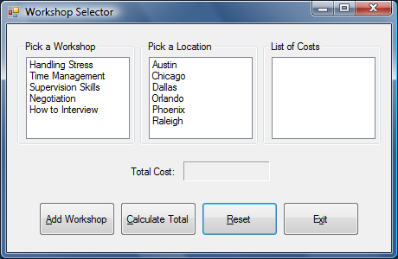
Your Workshop Selector initial Form design is in the pane to the left.
- Use Group Boxes as on the Demo Solution
- Populate list boxes inside your code
- Allow selecting a workshop and location, and use .SelectedIndex property of listboxes to
Add Workshop (next, see Calculations below to add workshop cost to the List of Costs listbox)
- Validate that selections were made, and display appropriate error message if necessary

❑ (10 Points) Calculations
- You will have a list of constants for this program (see tables of values below).
These constants will be used to calculate subtotals to be added to the List of Costs list box. Format output appropriately using .ToString method
- Use Select Case with .SelectedIndex to assign the correct constants for calculation. When the Calculate Total button is clicked, the sum of the costs will be displayed in the total cost label using the .ToString method.

Workshop | Number of Days | Registration Fee
Handling Stress | 3 | 595.00
Time Management | 3 | 695.00
Supervision | 3 | 995.00
Negotiation | 5 | 1295.00
How to Interview | 1 | 395.00

Location information | Cost per day at location
Austin | 95
Chicago | 125
Dallas | 100
Orlando | 95
Phoenix | 92
Raleigh | 90

❑ (3 points) Program Documentation
Follow naming conventions and provide documentation as required (see above)

Overall 20 Points Possible
Copy and paste all your Source Code here:
' Ananta Bhandari
' IS 250, Project 2: States Information Program
' Project started: 07/20/2014, Project Submitted: 07/21/2014
' Purpose of the program: This application allows the user to add multiple workshops from list.
'The user can choose various workshops offered at different location as well.

Option Strict On
Public Class frmWorkshopSelector

Private Sub btnAddWorkshop_Click(sender As System.Object, e As System.EventArgs) Handles btnAddWorkshop.Click

'Variable to hold the Workshop
Dim dblWorkshop As Double

'variable to hold number of days
Dim intDay As Integer

'variable to hold Cost
Dim dblCost As Double

'Variable to hold Total
Dim dblTotal As Double

'Give Specific Number to all the items in list of Workshop
If lstWorkshop.SelectedIndex = -1 Then
MessageBox.Show("Please pick a workshop")
Return
End If
If lstLocation.SelectedIndex = -1 Then
MessageBox.Show("Please pick a workshop")
Return

End If

Select Case lstWorkshop.SelectedIndex
Case Is = 0
dblWorkshop = 595
intDay = 3
Case Is = 1
dblWorkshop = 695
intDay = 3
Case Is = 2
dblWorkshop = 995
intDay = 3
Case Is = 3
dblWorkshop = 1295
intDay = 5
Case Is = 4
dblWorkshop = 395
intDay = 1
End Select

Select Case lstLocation.SelectedIndex
Case Is = 0
dblCost = 95
Case Is = 1
dblCost = 125
Case Is = 2
dblCost = 100
Case Is = 3
dblCost = 95
Case Is = 4
dblCost = 92
Case Is = 5
dblCost = 90
End Select

'Calcualte the total cost
dblTotal = (dblCost * intDay) + dblWorkshop

'list the item as currency
lstListOfCosts.Items.Add(dblTotal.ToString("c"))
End Sub

Private Sub btnCalculateTotal_Click(sender As System.Object, e As System.EventArgs) Handles btnCalculateTotal.Click
Dim intTotalCost As Double
For Each Str As String In lstListOfCosts.Items
'sum items in list box for total cost
intTotalCost = intTotalCost + CDbl(Str)

Next
'put some of total cost to the lable of total cost
lblTotalCost.Text = intTotalCost.ToString("c")
End Sub

Private Sub btnReset_Click(sender As System.Object, e As System.EventArgs) Handles btnReset.Click
'Reset the List boxes
lstWorkshop.SelectedIndex = -1
lstLocation.SelectedIndex = -1
lstListOfCosts.Items.Clear()
lblTotalCost.Text = String.Empty
End Sub

Private Sub btnRemove_Click(sender As System.Object, e As System.EventArgs) Handles btnRemove.Click

With lstListOfCosts
' Check if selection is made
If .SelectedIndex <> -1 Then

'remove at selected position
.Items.RemoveAt(.SelectedIndex)
Else
MessageBox.Show("Select an item!")
End If
End With
End Sub

Private Sub btnRemoveAll_Click(sender As System.Object, e As System.EventArgs) Handles btnRemoveAll.Click
'Clear the listbox
lstListOfCosts.Items.Clear()
End Sub

Private Sub btnExit_Click(sender As System.Object, e As System.EventArgs) Handles btnExit.Click
'Close the form
Me.Close()
End Sub
End Class
Copy all your Windows forms (using Alt-PrntScrn) at run-time and paste here with comments as needed.

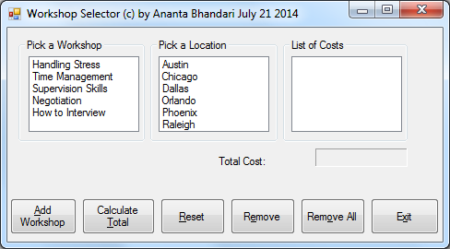

Screen Shot 1: Initial startup screen of application

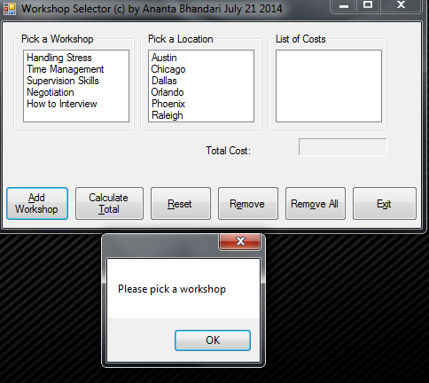

Screen Shot 2: Message box prompts when workshop is not selected

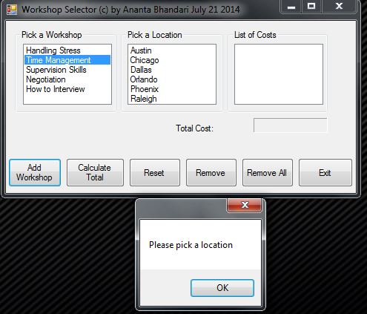

Screen Shot 3: Message box prompts when location is not selected

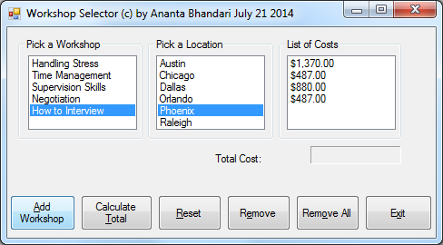

Screen Shot 4: Workshop is added by clicking on add workshop button.

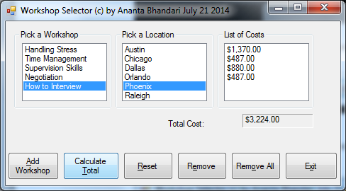

Screen Shot 5: Total Cost is Displayed at label.

Additional features: Reset clears all the labels and list boxes. Remove button is used to remove any workshop cost from List of Costs. Clicking on Remove All button, removes all the costs from the List of Costs. Exit button is used to exit an Application.

Ananta Bhandari Project 3: States Information Program
Work Planning | Implementation Notes | Time Date:
Identified the execution method  Made a Blue Print for GUI  Created Labels, List boxes, and Buttons  Renamed all the labels  Started to code for the Project  Programmed using If then else and select case  Debug using break point  Submitted for Grading | Aligned labels and Buttons boxes properly  Used proper naming convention  Used Dim, select case, selected index methods to identify items from list boxes and assign the fee accordingly.  Reworked on logical arguments.  Used step In and Step out to debug code one line at a time. | 9:00 am 07/20/2014  9:20 am  9:30 am  9:35 am  12:00 pm  10:00 am 07/21/2014  2:00 pm

